**Exploring temperature and precipitation changes across 21st Century Europe**

**Abstract**

This paper explores projected ensemble average changes in near surface temperature (°C ) and total near-surface precipitation (mm/day), both annually and seasonally (JJA and DJF), across 21st Century Europe under the RCP4.5 scenario. These projections are sourced from CORDEX EUROPE model simulations and assess changes in the near-term (2021-2040), mid-term (2041-2060) and long-term (2081-2100) relative to the beginning of the 21st Century (1981-2010). Hindcasting against historical E-OBS data (1980-2015) displays general alignment, whilst highlighting biases particularly over mountainous regions and the Mediterranean. Robust warming is projected by the end of the century, especially in Northeast Europe, with precipitation changes being more prominent in the North, although this is much more uncertain. These findings emphasize the importance of communicating regional climate projections, along with their uncertainties, to inform adaptive decisions across Europe.

**Introduction**

It is stated with high confidence that the global warming and the increased frequency, and intensity of precipitation since 1950 is attributable to anthropogenic emissions, and is very likely to continue into the 21st Century (Intergovernmental Panel on Climate Change, 2022). Europe is the fastest warming continent, with weather extremes such as flooding, droughts and heatwaves becoming more intense and frequent over the last few decades (Intergovernmental Panel on Climate Change, 2021). This has significant socioeconomic impacts, with the European Union estimating an economic loss of around €162 billion between 2021-2023 due to weather and climate extremes (European Environment Agency, 2023). As a result, the European Union has implemented mitigation and adaptation strategies for future climate change, such as the long-term plan to become Carbon Neutral by 2050 (Fetting, 2020). In order to make informed strategies, it is crucial to understand climate changes at a regional scale, although this is met with great uncertainty (Lionello et al, 2006; Kjellström et al, 2011).

Various uncertainties exist when simulating future climate change, including the emissions trajectory, the amplitude and distribution of climate change, and how much of this signal is masked by internal variability (Kjellström et al, 2011). A common approach in contemporary climate research is to use various General Circulation Models (GCMs) to produce ensemble averages over multiple emission scenarios (Kjellström et al, 2011; Cattiaux et al, 2014). A plethora of GCMs have been downscaled to finer scales in order to model European climate change, all of which have their own benefits and drawbacks (Hewitt, 2004; van der Linden and Mitchell, 2009; Christensen and Christensen, 2007; Déqué et al, 2007; Jacob et al, 2007; Haugen and Iversen, 2008). This study aims to contribute to this scientific domain by assessing changes in near-surface temperature (°C) and total near-surface precipitation (mm/day) across 21st Century Europe, under the Relative Concentration Pathway 4.5 (RCP4.5). These changes will be explored annually, alongside the summer months of June, July, August (JJA) and the winter months of December, January, February (DJF).

**Methods**

This research makes use of the CORDEX Europe GCM outputs and E-OBS observational dataset given from the IPCC Interactive Atlas (IIA) (IPCC Interactive Atlas, 2021).  Hindcasting of the 20th Century is undertaken to assess the accuracy of the models, before the projected changes across 21st Century Europe are discussed (Haylock et al, 2008; Klok and Klein Tank, 2008; Kjellström et al, 2011). These datasets are structurally similar and therefore no transformational techniques are required for hindcasting (Kjellström et al, 2011; Jacobs et al, 2014).

The robustness of the projections are tested using the simple and advanced uncertainty scales that the IIA provides (IPPC Interactive Atlas, 2021). The IIA displays spatial uncertainties using a hatching system which is not provided in this report but is commented on within the discussion. The key uncertainties considered in this research are categorised in Table 1 below.

Table 1: Highlights and describes the classification metrics used to assess the significance of the simulated climate changes in this study.

|  |  |
| --- | --- |
| **Classification** | **Description** |
| **Robust / Statistically Significant** | More than 66% of the models indicate a change that exceeds the climate internal variability threshold, with more than 80% of the models agreeing on the direction of change. |
| **High Model Agreement** | More than 80% of the models agree on the direction of change |

**Results**

Hindcasting

For temperature, the hindcasting is relatively comparable to the observations, with the models consistently underestimating the mean temperature by up to 2°C, for a large proportion of Europe annually and seasonally (Fig1). The greatest underestimates are visible at the Alps and Scandinavia, with temperature differences between 3-4°C across all domains (Fig1). Despite the models simulating a general cooler climate, there is a clear overestimation of temperatures in the Mediterranean by ~2°C, which are most prominent in DJF (Fig1).

For precipitation, the models consistently simulate wetter conditions on average across the majority of Europe by ~1mm/day (Fig1). The greatest precipitation rates are experienced in DJF, with the Mediterranean and Scandinavia displaying ~3mm/day more than the observations (Fig1). During JJA these overestimations are restricted more towards the Alps and Scandinavia (Fig1). The annual and winter trends are relatively similar, however during JJA the model simulations underestimate average precipitation rates over regions of Eastern Europe such as Ukraine, Belarus and Romania by ~1mm/day; which is not seen in any other domain (Fig1).

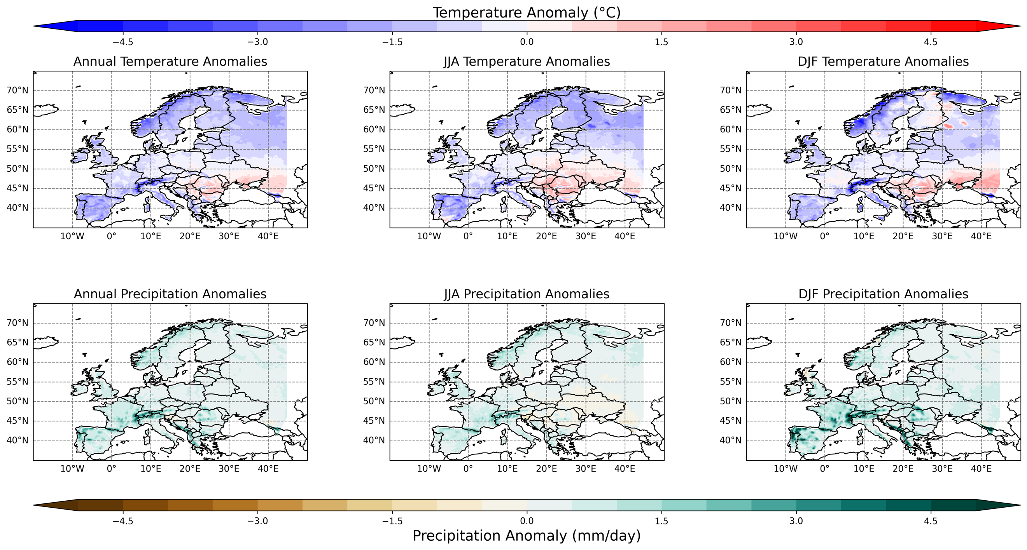

Fig1: Spatial plots displaying the average temperature and precipitation anomalies between the CORDEX Europe historical simulations (1981-2010) and the E-OBS historical observations (1980-2015). These differences are shown for Annual, JJA and DJF. The graphs subtract the CORDEX Europe simulations from the E-OBS data, meaning that the anomalies are a result of simulation differences. For example, a high temperature anomaly indicates overestimated warming by the model.

Future Projections

The simulations display statistically significant heterogeneous warming across Europe by 2100, both annually and seasonally, with the majority of warming occurring within 2°C (Fig2). For the near-term and mid-term, this significance is true for approximately 70% and 95% of Europe respectively (not shown). This significance is highlighted particularly well in Fig3, which shows that all of the model simulations in the 90th interpercentile range show a warming trend. There is a visible Southwest to Northeast warming gradient which reaches up to 5°C by 2100 for all domains (Fig2).

Precipitation trends are more heterogeneous, with model projections simulating consistent drier conditions in Southern Europe by up to 30% (Fig2). There is also high model agreement for projected wetter conditions in Northern European regions by up to 30% by 2100 (Fig2). The dry-wet border appears to migrate from North to South throughout the year (Fig2). It appears that precipitation in the Northern regions could be in line with projected warming, with an increase of ~6% per °C of warming in Scandinavia (Fig2).

For DJF, there is high model agreement on the increase in precipitation in Central and Northeast Europe, as well as Scandinavia by 2100 (not shown). This agreement is evidenced in Fig3, which shows that all model simulations in the 90th interpercentile range, project at least 1% more precipitation relative to the beginning of the century. In JJA, there is little agreement on the sign of precipitation change across Europe, with ~90% of Europe not showing a robust signal (not shown). The precipitation uncertainties are largest in JJA, with an interquartile range of ~3% which fluctuates between negative and positive values (Fig3). This is the only scenario in which the uncertainties are negative (Fig3). For both temperature and precipitation, the statistical significance generally increases across the 21st century for all timescales (Fig3).

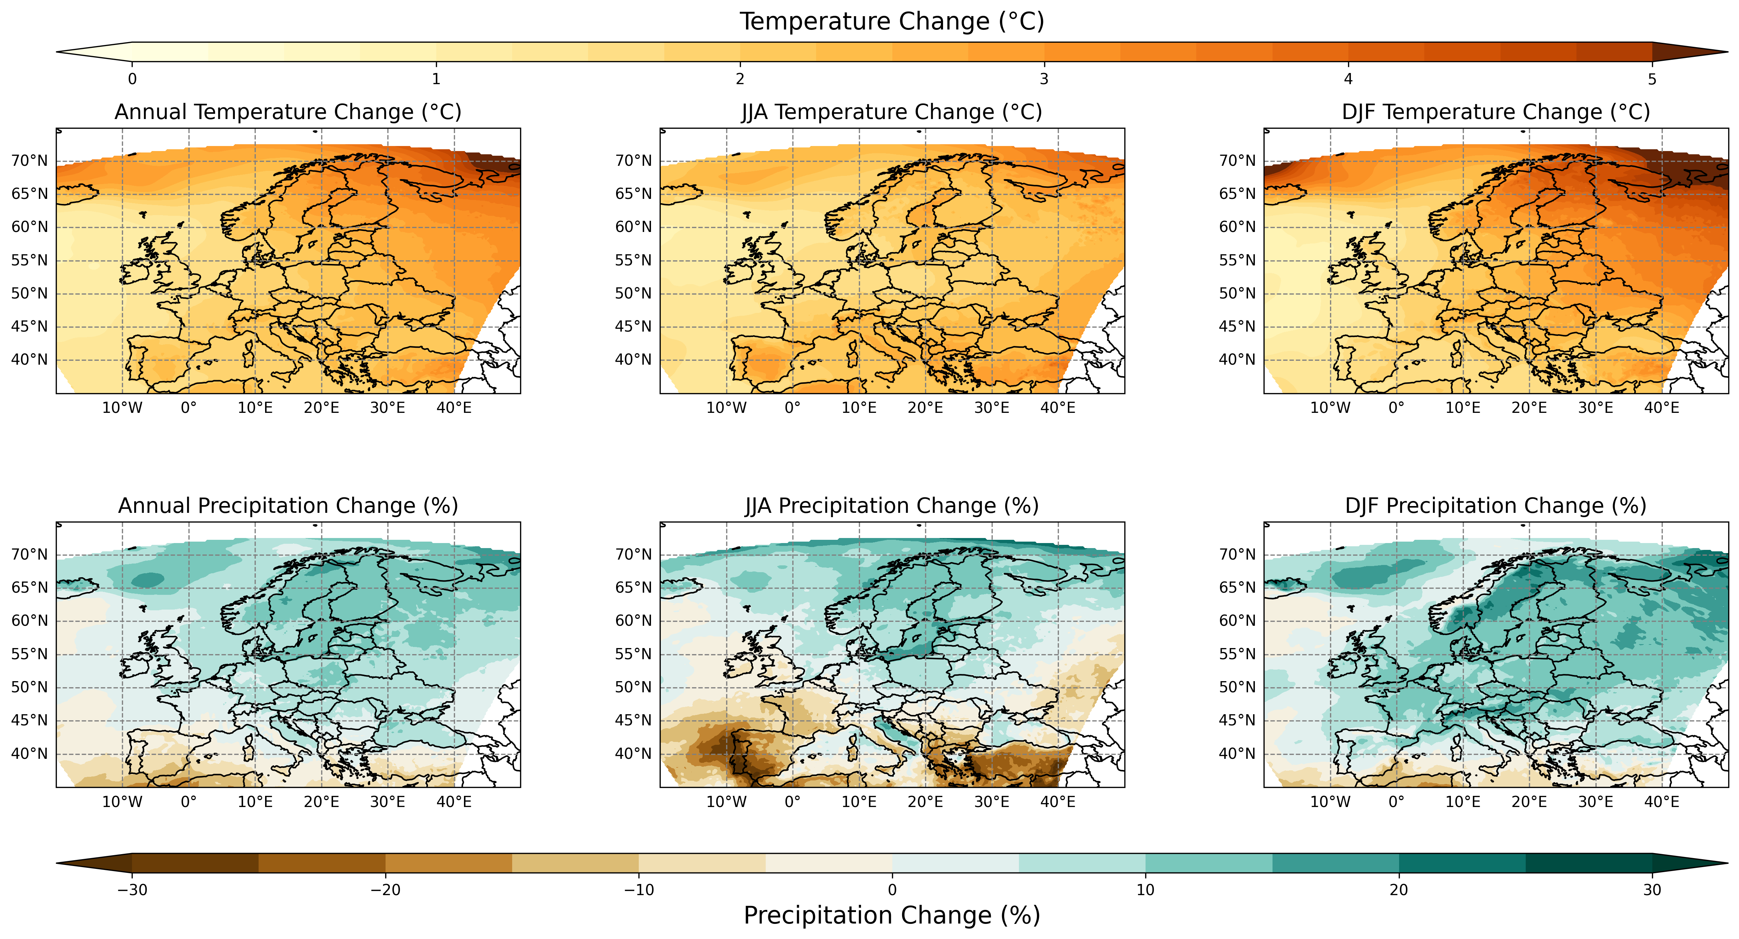

Fig2: Spatial plots showing the ensemble average changes in temperature (°C) and precipitation (%) by the end of the century (2081-2100) relative to the beginning of the century (1981-2010) under the RCP4.5 emission scenario. This is shown annually, and across JJA and DJF.

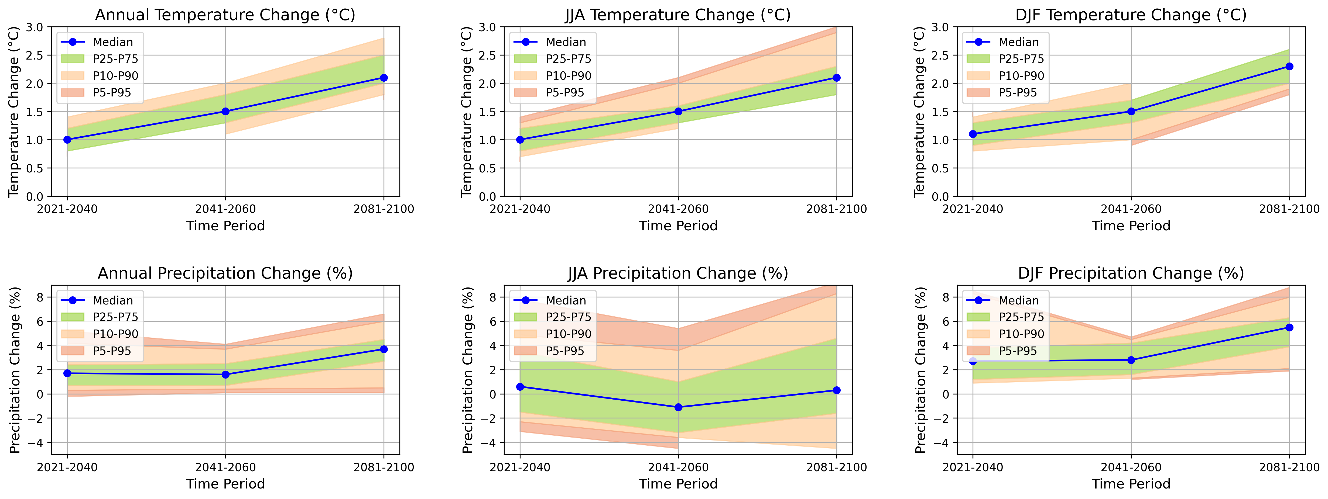

Fig3: Timeseries to show the median changes (blue line) in temperature(°C) and precipitation (%) across the 21st Century relative to the beginning of the century (1981-2010). This is split into three time intervals: 2021-2040, 2041-2060 and 2081-2100. The uncertainty percentile (P) ranges are given as: P25-P75 (green shading), P10-P90 (orange shading) and P5-P95 (red shading). This is shown annually and across JJA and DJF.

**Discussion**

The hindcasting is largely consistent with similar studies (Samuelsson et al, 2011; Kjellstöm et al, 2011). Research suggests that the general discrepancies between the observations and the hindcasting could be attributed to difficulties of representing the North Atlantic current and the El Niño-Southern Oscillation in GCMs (van Oldenborgh et al, 2009; Basharin et al, 2016). The warmth anomaly over the Mediterranean is consistent with similar research, and can be largely explained through land cover differences that are disregarded when GCMs calculate gridded spatial averages (Kjellström et al, 2011, Nikulin et al, 2011, Samuelsson et al, 2011). The precipitation hindcasting is relatively consistent with existing research, with the work of Kjellström (2011) showing regional biases exceeding 100% in Scandinavia. However, the work of Kjellström (2011) underestimates precipitation by ~15% over the Alps, which is controversial to this study. Research suggests that the fluctuations in these regions can be explained by the regions topography with precipitation commonly being overestimated in mountainous regions and weakened in the neighbouring lowland areas (Kjellström et al, 2011). Although the hindcasts do not simulate historical observations perfectly, the results are consistent with other GCM driven research, which reinforces confidence in the subsequent projections (Kjellström et al, 2011; Vautard et al, 2014).

The increasingly robust warming by the end of the century is consistent with existing literature and is largely explained through the projected reduction in Mean Sea Level Pressure (MSLP) and resultant cyclonic activity in the Mediterranean, which leads to increased zonal flow to Northern Europe (Bengtsson et al, 2006; Polonsky, 2008; Kjellström et al, 2011; Basharin et al, 2016). The explanation for the projected extreme warming in Northeastern Europe extends beyond MSLP changes (Kjellström et al, 2011). Although it may have some effect, these extremes are strongly correlated to the reduction in Arctic sea-ice and snow cover; although it is difficult to ascertain whether this is a causal effect or merely a by-product of these processes (Chapin et al, 2005; Perovich et al, 2007; Kjellström et al, 2011).

The projected precipitation trends are largely consistent with similar research, especially for JJA displaying highly uncertain changes (Kjellström et al, 2011; Vautard et al, 2014). Although there is high agreement for average wetter conditions in North European regions, the large majority of these trends are not statistically significant, apart from in Northeastern Europe and Scandinavia (not shown), where there appears to be a link between temperature and precipitation. This aligns well with existing literature which suggests that the temperature-moisture holding capacity feedback is effective in these regions (Christensen and Christensen, 2007; Kjellström et al, 2011). Research also suggests that changes in circulation may be influencing these trends, however it is not the main driver (Kjellström et al, 2011). The rate of precipitation increase is comparable to the value of 5.6%/°C stated in Kjellström (2011) however this is very high relative to the observed rate of 4%/°C of warming (Held and Soden, 2006). These differences are likely due to the amplification of precipitation in these regions, which was highlighted in the hindcasts (Kjellström et al, 2011).

**Conclusions**

This research has highlighted the spatial and seasonal heterogeneity in temperature and precipitation changes across 21st Century Europe. Temperature trends appear to be more robust, with a clear Southwest to Northeast warming gradient, whereas precipitation uncertainties show greater fluctuations, especially over JJA. The hindcasts and simulated results are consistent with existing literature, which reinforces the complexity of the climate system by displaying the inherent uncertainties that exist when projecting future climate on a regional scale. Successful communication of these projections and their associated uncertainties is critical for implementing effective regional adaptive strategies.

**References**

**References**

* Basharin, D., Polonsky, A. and Stankūnavičius, G., 2016. Projected precipitation and air temperature over Europe using a performance-based selection method of CMIP5 GCMs. Journal of Water and Climate Change, 7(1), pp.103-113.
* Bengtsson, L., Hodges, K.I. and Roeckner, E., 2006. Storm tracks and climate change. Journal of climate, 19(15), pp.3518-3543.
* Cattiaux, J., Douville, H. and Peings, Y., 2013. European temperatures in CMIP5: origins of present-day biases and future uncertainties. Climate dynamics, 41, pp.2889-2907.
* Chapin III, F.S., Sturm, M., Serreze, M.C., McFadden, J.P., Key, J.R., Lloyd, A.H., McGuire, A.D., Rupp, T.S., Lynch, A.H., Schimel, J.P. and Beringer, J., 2005. Role of land-surface changes in Arctic summer warming. science, 310(5748), pp.657-660.
* Christensen, J.H. and Christensen, O.B., 2007. A summary of the PRUDENCE model projections of changes in European climate by the end of this century. Climatic change, 81(Suppl 1), pp.7-30.
* Déqué, M., Rowell, D.P., Lüthi, D., Giorgi, F., Christensen, J.H., Rockel, B., Jacob, D., Kjellström, E., De Castro, M. and Van Den Hurk, B.J.J.M., 2007. An intercomparison of regional climate simulations for Europe: assessing uncertainties in model projections. Climatic Change, 81, pp.53-70.
* European Environment Agency (2023) *Economic losses from weather- and climate-related extremes in Europe*. Available at:<https://www.eea.europa.eu/en/analysis/indicators/economic-losses-from-climate-related> (Accessed: 9 November 2024).
* Fetting, C., 2020. The European green deal. ESDN Report, December, 2(9).
* Haugen, J.E. and Iversen, T., 2008. Response in extremes of daily precipitation and wind from a downscaled multi-model ensemble of anthropogenic global climate change scenarios. Tellus A: Dynamic Meteorology and Oceanography, 60(3), pp.411-426.
* Held, I.M. and Soden, B.J., 2006. Robust responses of the hydrological cycle to global warming. Journal of climate, 19(21), pp.5686-5699.
* Hewitt, C.D., 2004. Ensembles‐based predictions of climate changes and their impacts.
* Intergovernmental Panel on Climate Change (2022) *Climate Change 2022: Impacts, Adaptation and Vulnerability. Summary for Policymakers*. Available at:<https://www.ipcc.ch/site/assets/uploads/sites/2/2022/06/SPM_version_report_LR.pdf> (Accessed: 9 November 2024).
* Intergovernmental Panel on Climate Change (2021) *AR6 Climate Change 2021: The Physical Science Basis. Regional Fact Sheet – Europe*. Available at:<https://www.ipcc.ch/report/ar6/wg1/downloads/factsheets/IPCC_AR6_WGI_Regional_Fact_Sheet_Europe.pdf> (Accessed: 9 November 2024).
* Jacob, D., Bärring, L., Christensen, O.B., Christensen, J.H., Hagemann, S., Hirschi, M., Kjellström, E., Lenderink, G., Rockel, B., Schär, C. and Seneviratne, S.I., 2007. An inter-comparison of regional climate models for Europe: design of the experiments and model performance. Climatic Change, 81(Supplement 1), pp.31-52.
* Perovich, D.K., Light, B., Eicken, H., Jones, K.F., Runciman, K. and Nghiem, S.V., 2007. Increasing solar heating of the Arctic Ocean and adjacent seas, 1979–2005: Attribution and role in the ice‐albedo feedback. Geophysical Research Letters, 34(19).
* Polonsky, A.B., 2008. The role of the ocean in climate change. Kiev: Nauk. dumka.
* van der Linden, P. and Mitchell, J.E., 2009. ENSEMBLES: Climate Change and its Impacts: Summary of research and results from the ENSEMBLES project. Met Office Hadley Centre, FitzRoy Road, Exeter EX1 3PB, UK, 160.
* van Oldenborgh, G.J., Drijfhout, S., Van Ulden, A., Haarsma, R., Sterl, A., Severijns, C., Hazeleger, W. and Dijkstra, H., 2009. Western Europe is warming much faster than expected. Climate of the Past, 5(1), pp.1-12.
* Vautard, R., Gobiet, A., Sobolowski, S., Kjellström, E., Stegehuis, A., Watkiss, P., Mendlik, T., Landgren, O., Nikulin, G., Teichmann, C. and Jacob, D., 2014. The European climate under a 2 C global warming. Environmental Research Letters, 9(3), p.034006.
* Jacob, D., Petersen, J., Eggert, B., Alias, A., Christensen, O., Bouwer, L., Braun, A., Colette, A., Déqué, M., Georgievski, G., Georgopoulou, E., Gobiet, A., Menut, L., Nikulin, G., Haensler, A., Hempelmann, N., Jones, C., Keuler, K., Kovats, S. & Yiou, P., 2014. EURO-CORDEX: New high-resolution climate change projections for European impact research. *Regional Environmental Change*, 14, pp.563–578. doi:10.1007/s10113-013-0499-2.

Kjellström, E., Nikulin, G., Hansson, U.L.F., Strandberg, G. and Ullerstig, A., 2011. 21st century changes in the European climate: uncertainties derived from an ensemble of regional climate model simulations. *Tellus A: Dynamic Meteorology and Oceanography*, *63*(1), pp.24-40.

IPCC Interactive Atlas, 2021. *IPCC WGI Interactive Atlas on Regional Climate Change*. Intergovernmental Panel on Climate Change. Available at: <https://interactive-atlas.ipcc.ch/regional-information> [Accessed: 10th November 2024].

Lowe, J.A., Bernie, D., Bett, P., Bricheno, L., Brown, S., Calvert, D., Clark, R., Eagle, K., Edwards, T., Fosser, G. and Fung, F., 2018. UKCP18 science overview report. *Met Office Hadley Centre: Exeter, UK*, pp.1-73.

Meinshausen, M., Smith, S.J., Calvin, K., Daniel, J.S., Kainuma, M.L., Lamarque, J.F., Matsumoto, K., Montzka, S.A., Raper, S.C., Riahi, K. and Thomson, A.G.J.M.V., 2011. The RCP greenhouse gas concentrations and their extensions from 1765 to 2300. *Climatic change*, *109*, pp.213-241.

Samuelsson, P., Jones, C.G., Will´ En, U., Ullerstig, A., Gollvik, S., Hansson, U.L.F., Jansson, E., Kjellstro¨ M, C., Nikulin, G. and Wyser, K., 2011. The Rossby Centre Regional Climate model RCA3: model description and performance. *Tellus A: Dynamic Meteorology and Oceanography*, *63*(1), pp.4-23.

Nikulin∗, G., Kjellstro¨ M, E., Hansson, U.L.F., Strandberg, G. and Ullerstig, A., 2011. Evaluation and future projections of temperature, precipitation and wind extremes over Europe in an ensemble of regional climate simulations. *Tellus A: Dynamic Meteorology and Oceanography*, *63*(1), pp.41-55